Five Digit Up Counter
Send Feedback

This assignment is an extension to the previous assignment and creates a timer that can take number till '99999'.

This is surely a difficult one, but you can solve it if you give a thought about it. Also, do not forget to create a responsive design for the counter.

Below is given the image for the timer you have to build -
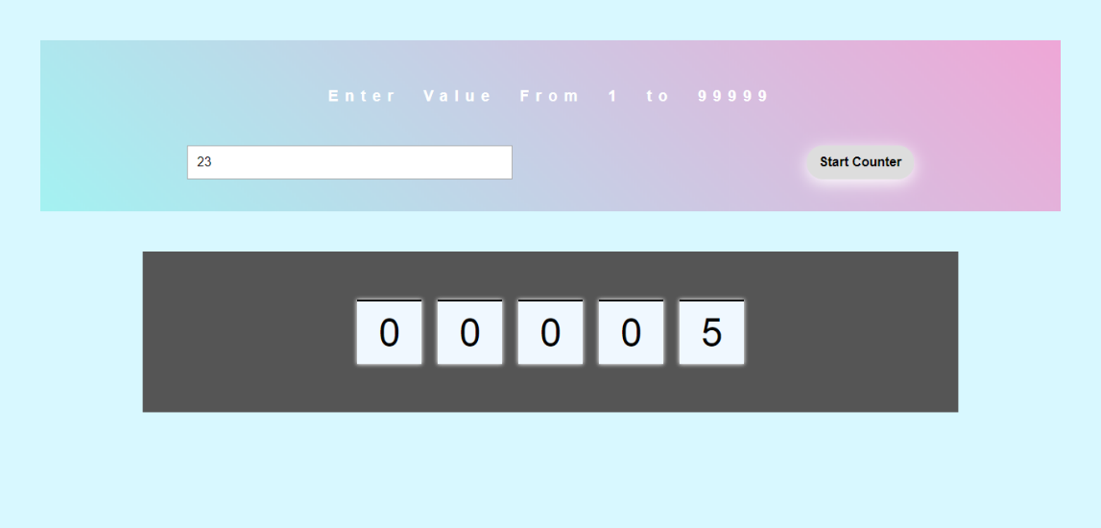

Gif for this problem is -
